IB Business Management Fundraiser
Snack Pack Only $10
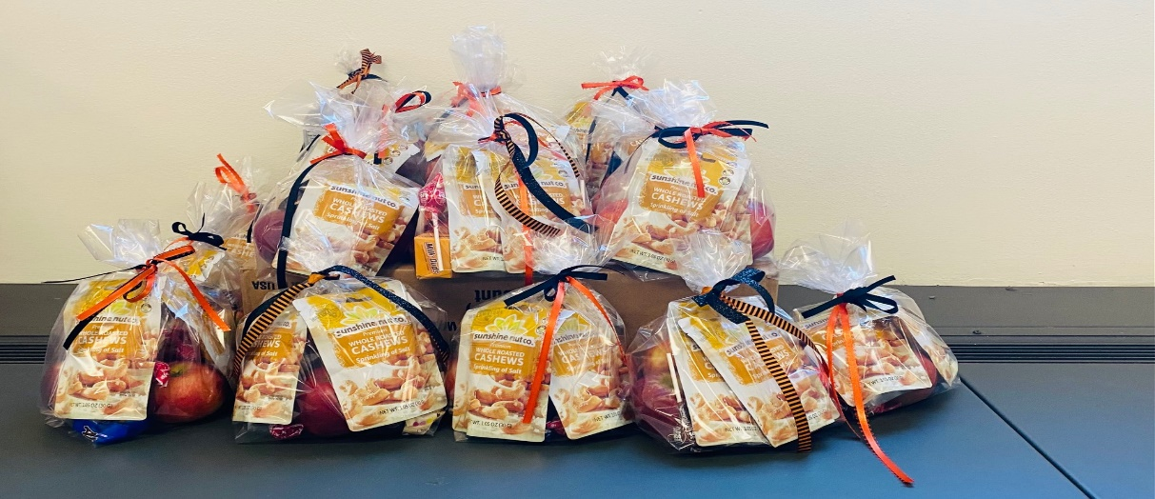
Contains 3 Hudson Valley Apples, 2 bags Sunshine Nut Co Cashews and a few sweet treats

One of the projects that the IB Business Management students have been working on is to build a relationship with a company that I visited studying ethical and sustainable business practices, The Sunshine Nut Company in Mozambique. We sponsor the education of three kids living at one of the Sunshine houses. This year we are collaborating with the Hudson Valley Apple Project to provide a snack pack. Your support is appreciated and 100 percent of funds go to education.
Please watch the story of the Sunshine Nut Company.
Who is Sunshine Nut Company?
