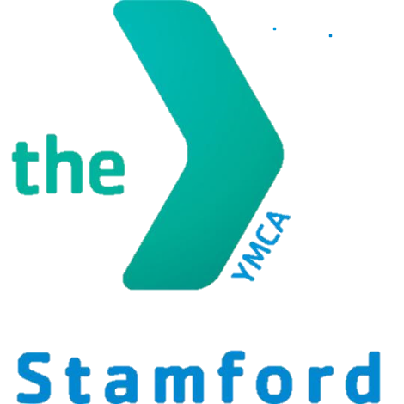

**Alexis Farrow**

**Program Coordinator**   
Phone: 203-357-7000

Email: alexis@stamfordymca.org

**Each L.E.A.D Academy Student will be expected to:**

* **Set & Achieve Personal Goals**
* **Complete an academic portfolio**
* **Perform 30 hours of volunteer service**
* **Maintain satisfactory grades**

L.E.A.D Academy is a free afterschool and summer program for all Stamford High School Students. Joining L.E.A.D you will receive:

* Academic Enrichment & Tutoring from certified educators
* College & Career Readiness
* Aquatics Lessons & Personal Training
* Multiple In-House Clubs & Activities
* A Study Plan personalized for each individual student
* Community Service & Volunteer Hours
* Field Trips
* Career and Internship Placement
* A Free YMCA Membership

**YMCA L.E.A.D ACADEMY**